    - Which browser was used last on this computer and when?
(Please provide the correct timestamp in the format: 2021-02-16 18:32:25 TIMEZONE)

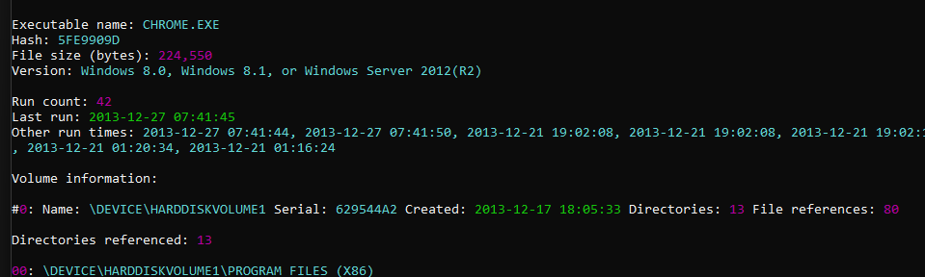
Chrome at 2013-12-27 07:41:45

    - Did the user ever launch the Snipping Tool? If yes when? (Please provide timestamp, as previously)
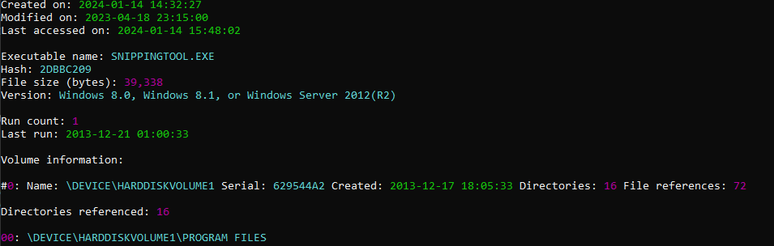
Yes. Snipping Tool was launched at 2013-12-21 01:00:33

    - Was GIMP launched the day it was installed? What day was it? (e.g. 2021-02-16 TIMEZONE)
Yes it was launched the day it was installed on:
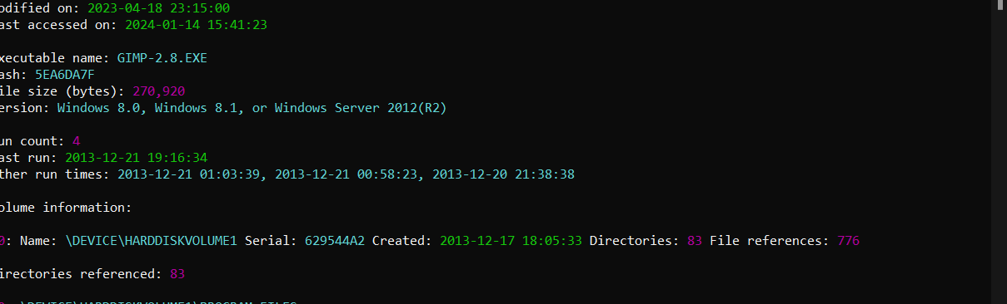
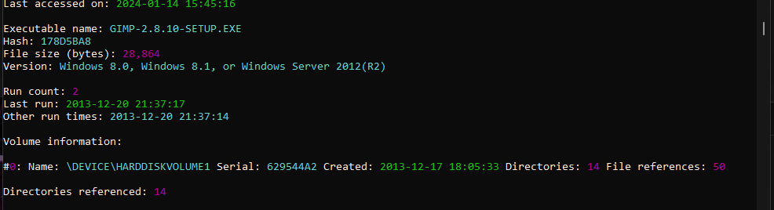
2013-12-20 21:38:38

    - How many times Google Chrome was run on this PC?

Chrome has been run 42 times on this PC.

